Market Property of the Week Guide

This document will guide you through updating the “Market Property of the Week” for <http://pvscottsdale.com/>. This guide assumes you are already logged into the Wordpress admin panel (<http://pvscottsdale.com/wp-admin/>) and have sufficient permission. If any step on this guide does not work properly, contact the site administrator for additional assistance.

# Update Images

## Remove Old Images

1. Click “Media” on the left menu  
   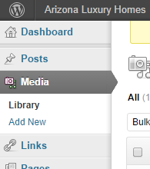
2. Check the box to the left of each image that is related to the previous “New to the Market Property of the Week”   
   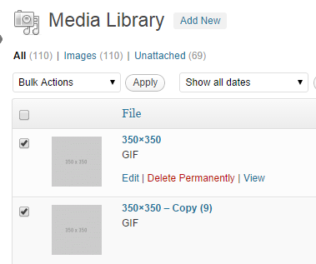
3. In the “Bulk Actions” drop down, choose “Delete Permanently”, then click the “Apply” button  
   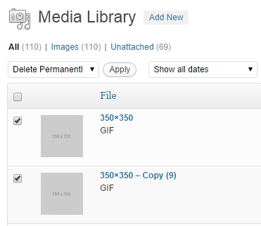

## Add New Images to Gallery

1. Click “Pages” on the left menu  
   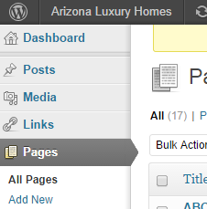
2. Locate and click “New to the Market Property of the Week”  
   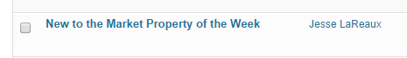
3. Make sure you’re in “Visual” mode  
   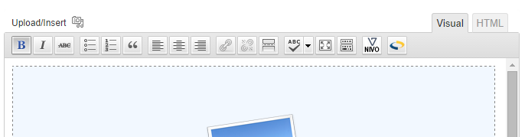
4. Click on the gallery placeholder (blue rectangle) and then click “Edit Gallery”  
   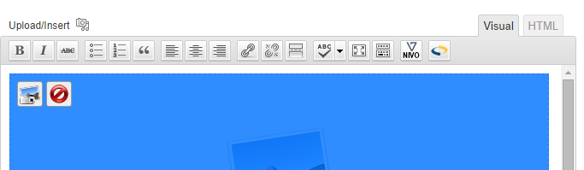
5. Click the “From Computer” tab at the top of this popup  
   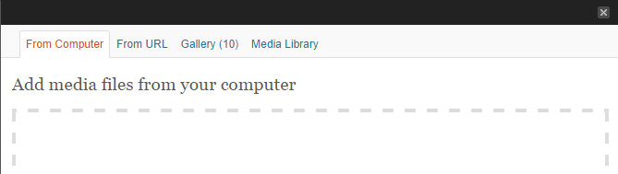
6. Drag and drop all images for this property into the dropzone  
   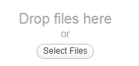
7. Click “Save all changes” to finalize  
   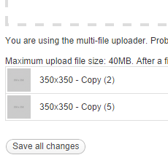

# Update Page Content

## Generate New HTML code

1. Visit <http://pvscottsdale.com/tools/market-property-of-the-week-generator/> and fill in all fields (if you need any additional instruction on this tool, see last page of this document) and fill in all needed fields (Price, MLS, and Address fields are required)  
   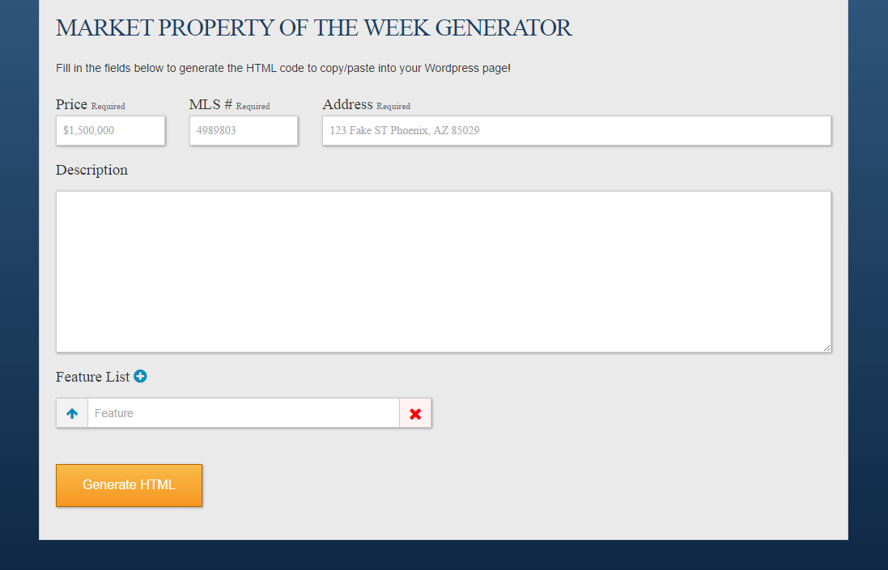
2. Click the “Generate HTML” button to submit your completed form  
   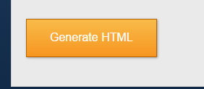
3. Click into the textarea and select all text (WIN: ctrl+a | MAC: cmd+a), then copy the selected text to your clipboard (WIN: ctrl+c | MAC: cmd+c)  
   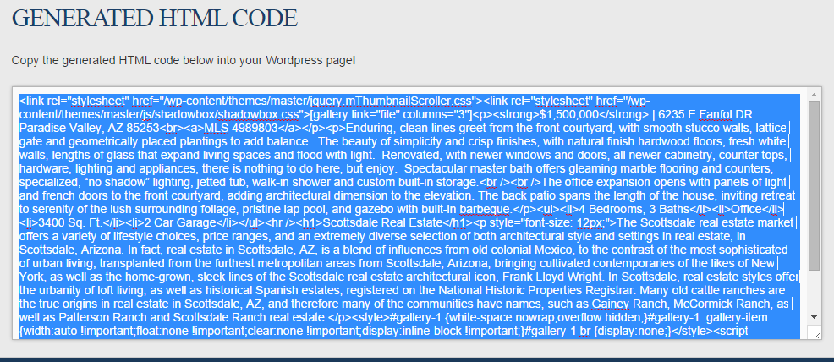

## Replace Page Content with Newly Generated HTML

1. Return to the Wordpress admin panel (<http://pvscottsdale.com/wp-admin/>) **\*If you need to log back in, DO NOT copy/paste your password, it will clear your clipboard and you’ll lose the code copied in the previous step**
2. Click “Pages” on the left menu  
   
3. Locate and click “New to the Market Property of the Week”  
   
4. Make sure you’re in “HTML” mode  
   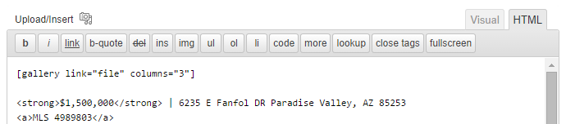
5. Click into the content text area and select all text (WIN: ctrl+a | MAC: cmd+a), then paste the new code into the page (WIN: ctrl+v | MAC: cmd+v)  
   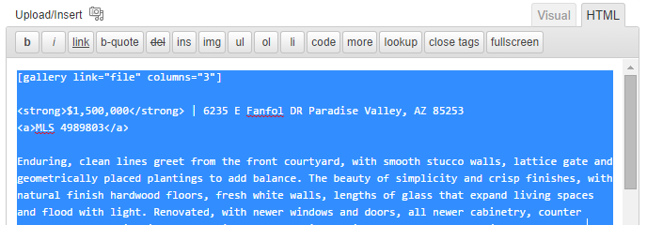
6. Click “Update” on the right to save this page **\*Be sure you do not switch back to “Visual” mode. It can break the formatting of this new page and you’ll have to generate the HTML again.**

# Market Property of the Week Generator Specific Instructions

This section will explain, in detail, how to use the HTML generator tool (<http://pvscottsdale.com/tools/market-property-of-the-week-generator/>)

## Price Field

The price field is required. You will not be allowed to generate new HTML code while this field is empty.

### Price Validation

The price field requires specific validation. The requirement is USD currency formatting: $xxx,xxx,xxx (no decimal places necessary, but they are accepted values)

## MLS # Field

The MLS # field is required. You will not be allowed to generate new HTML code while this field is empty.

### MLS # Validation

This field can only be numbers, no symbols or letters will be allowed.

## Address Field

The price field is required. You will not be allowed to generate new HTML code while this field is empty.

## Description Field

This is a simple text field that will accept all characters, no validation rules apply. Any new lines (‘return’ or ‘enter’ key) will force a line break in the final code.

## Feature List

This is where you can list the features of a property (3 bedrooms, 2 bathrooms, office, etc).

1. To add an additional feature, click the “+” button  
   
2. To reorder features, click the “↑” button. This will move the selected feature one position closer to the top of the feature list  
   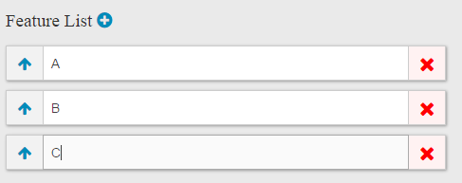
3. To remove a feature, click the “X” button  
   